Xiaoru Chen

chenxia2@oregonstate.edu

Project #0

CS 475/575

2021-04-05

**Machine I ran this on:**

I used my MacBook pro to ssh to OSU ENGR server.

**Key snippets of code:**

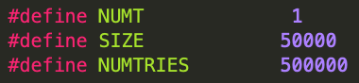

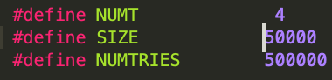

**Performance results:**

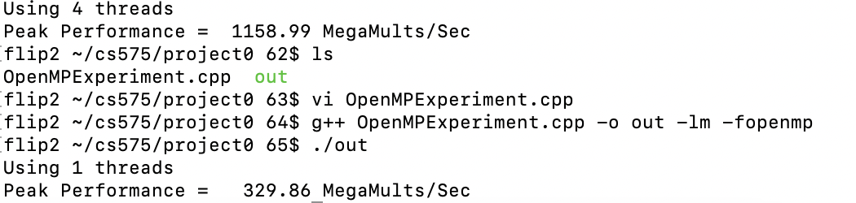

**Speedup:**

$$S=\frac{Performance with four threads}{Performance with one thread}=\frac{\left(1158.99\left(\frac{MegaMults}{Sec}\right)\right)}{\left(329.86\left(\frac{MegaMults}{Sec}\right)\right)}=3.514$$

**Parallel fraction:**

$$Fp=\left(\frac{4}{3}\right)*\left(1-\left(\frac{1}{S}\right)\right)=\left(\frac{4}{3}\right)*\left(1-\left(\frac{1}{3.514}\right)\right)=0.954$$

**Analysis:**

The speedup is 3.514, which is less than 4.0.

The four threads program finishes faster than the one thread program because it can proceed to work simultaneously. However, a multithreaded program needs to do extra work coordinating multiple threads when calculating. So the speedup cannot reach 4 times.